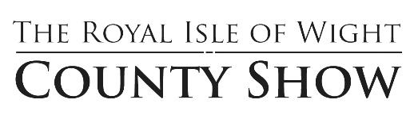

Royal Isle of Wight Agricultural Society County Show

Fun Dog Show organiser: P Cracknell

All day “Fastest Bonio” eating contest

Fun Dog Show 14.00.
Each class is limited in numbers and dogs must be entered prior to the show time, rosettes awarded to top 3 dogs

Fun Dog Show Classes

- Best cross breed
- Best pedigree
- Best rescue dog
- Best Puppy under 12 months
- Best condition coat – long/rough
- Best condition coat – short/smooth
- Prettiest bitch
- Most handsome dog
- Waggiest tail
- Prettiest eyes
- Best looking six legs
- Dog most like owner
- Dog the judge would like to take home
- Judge’s choice Best in Show (all previous 1st in class winners)

Fun Dog Show Rules:

- Entry fee is £2.00 per class per dog on the day.
- Show to commence at 14.00
- All entries to be registered by 13.45pm.
- Isle of Wight royal agriculture Society, its staff or any person relating to the society can not take any responsibility for any loss or damage caused to people, animals or property whilst on the showground.
- The committee reserves the right to alter or amend the schedule if necessary.
- All class winners automatically qualify for the best in show
- The judge’s decision is final.

